**Tesla coil**

Wireless transfer of electricity

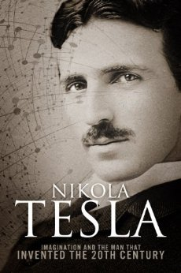

Viekash v k

**Table of Contents**

* Introduction
* History
* Types of tesla coil
* Theories
* Electromagnetic Induction
* Power Coupling
* Tesla coil circuit
* Working principle
* Application – Pros and Cons
* Mathematics used/involved
* Conclusion
* Bibliography

**Introduction:**

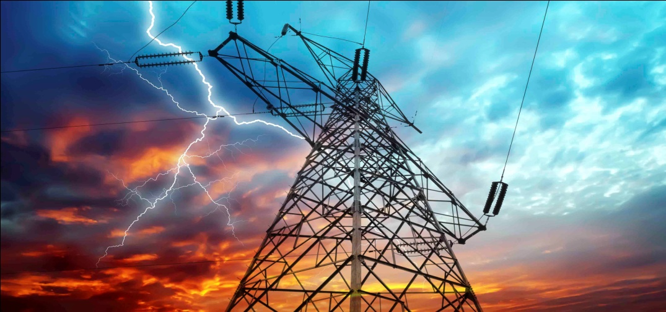

* In this era of modification,electricity has become unavoidable part of life.
* The major source of conventional distribution of electricity is through wires.
* One of the major issue in power system is losses during transmission and distribution of electrical power.
* The percentage loss in transmission and distribution is approx 26%.
* The main reason for power loss is the resistance of wires used in the grid.
* According to the World Resource Institute(WRI), India’s electricity grid has the highest transmission and distribution loss(25-40%).
* So Nikola Tesla’s idea of wireless transmission of electricity using electromagnetic induction can be adopted wherever possible.

**History:**

Sir Nikola Tesla was the first one to propose and research the idea of wireless transmission in 1899, since then many scholars and scientists have been working to make his work reality.

**1899:** Tesla continues wireless power transmission research in Colorado Springs and writes “The inferiority of the induction method would appear immense as compared with the disturbed charge of ground and air method”.

**1961:** William C Brown publishes an article exploring possibilities of microwave power transmission.

**2009:** Sony shows a wireless electrodynamics induction powered TV set. 60 watts over 50 cm.

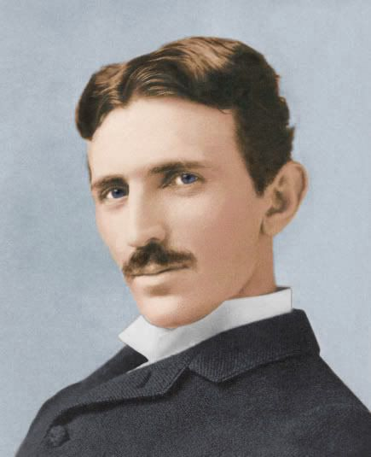

Experiments performed between 1888 and 1907 by Nicola Tesla.

* Started efforts on wireless transmission by 1891 in experimental station at Colorado.
* He lightened a small incandescent lamp by means of a Resonant circuit grounded on one end.
* In 1901 Tesla began construction of a large high voltage wireless power transmission now called the Wardendclyffe tower at Shoreham, New York.
* The idea of Tesla is taken research after 100 years by a team lead by Marine Soljacic from MIT.
* He used to lamp 200 lights from 40 kms distance.

**Types of tesla coil:**

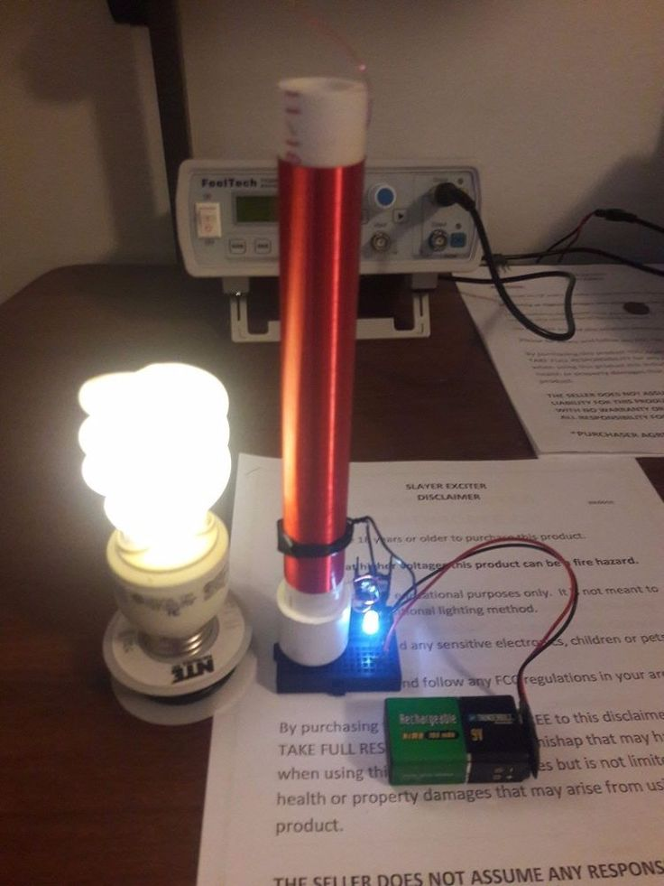

* Spark-excited or Spark Gap Tesla Coil(SGTC)
* Static Spark Gap
* Static Triggered Spark Gap
* Rotary Spark Gap
* Switched or Solid-State Tesla Coil(SSTC)
* Single resonant Solid-State Tesla Coil(SRSSTC)
* Dual Resonant Solid-State Tesla Coil(DRSSTC)
* Musical Tesla Coil
* Continuous Wave
* Two Coil or double resonant circuits
* Three coil triple-resonant, or magnifier circuits

**Theories:**

**Electromagnetic Induction**

It is the production of voltage across a conductor moving through a magnetic field.

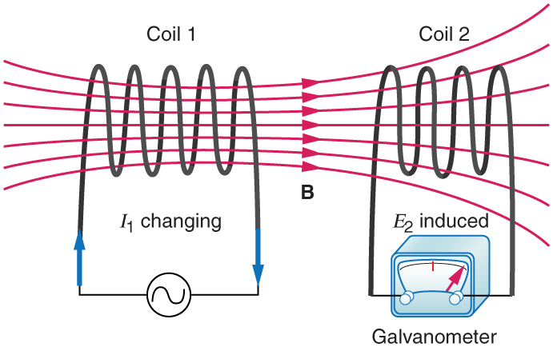

**Power Coupling**

Power coupling occurs when an energy source has a means of transferring energy to another object.

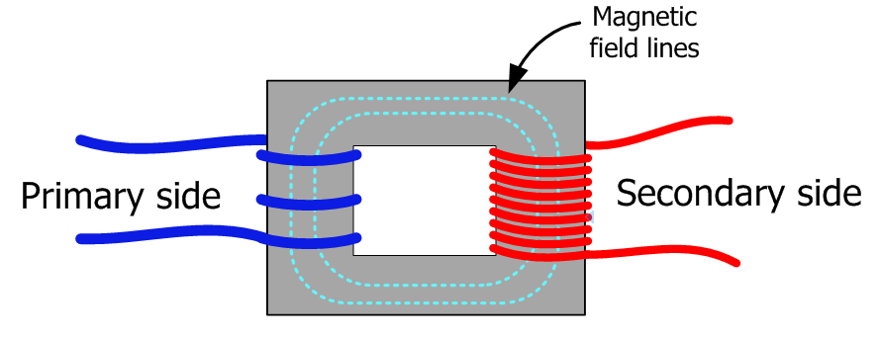

**Tesla coil circuit:**

Here we have a simple Tesla coil circuit which works on the basis of electro magnetic induction.

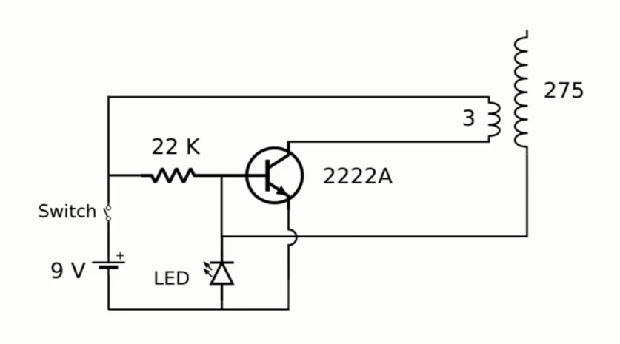

This circuit consists of different parts like,

**1.Inductors**:

Circuit’s primary and secondary coils are both inductors in electrical terms.They usually used to oppose the change in current passing through them but here they are used induce current.

**2.Capacitor:**

It stores energy in the form of electric field lines.It gets charged up in milli seconds and discharge even more faster like microseconds.

**3.Transistor:**

It is here used as an automatic switch which allows the collector current as long as the base current is less and switch off when it is more.

**4.Resistor:**

It is used to decrease the base current.

**Working principle:**

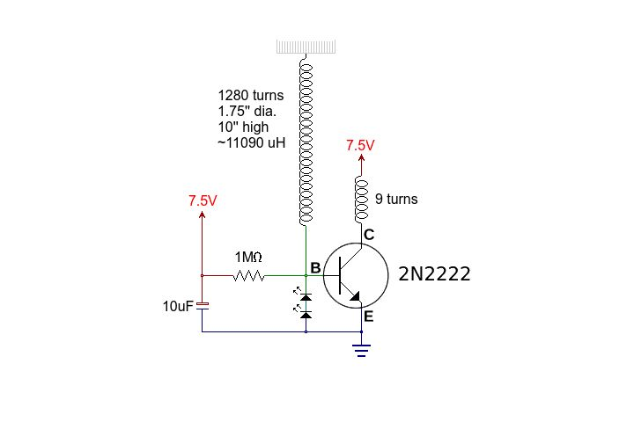

Wireless electricity uses the principle which involvesthe usage of inductively coupled objects with same resonant frequency.The principle of Electromagnetic induction states that a coil generating magnetic field induces current in another coil as it is being placed in the field of the former coil.

The input voltage is given to the primary coil as well as the transistors base and the other terminal is earthed. For the collector current to flow through the resistor base current should be less than this current and so we use a resistor to reduce the base current .So now the current starts flowing through the primary coil which induces current in the secondary coil and this current will add up to base current making it more which stops the flow of current and so everything will start from the beginning.This repeats again and again with a very high frequency.This oscillation is required for induction.

We use step up transformer concept here i.e,the voltage is increased in the secondary coil as we have more no. of turns in the secondary coil than primary coil,and the ratio of voltages in the coils will be equal to the ratio of their no. of turnsrespectively.Thus increasing the voltage and decreasing the current as VxI is constant as the energy(as well as power)is conserved.

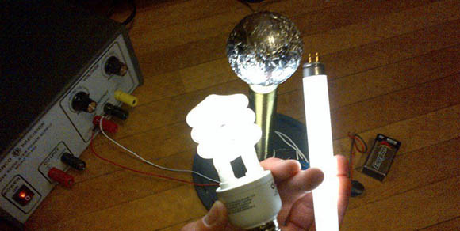

This high voltage is enough to ionise the air till some distance and so it lights any bulb brought near it and for other appliances there should be a reciever circuit which could capture this and change to the oscillation frequency of that appliance.This appliance olny works if the other terminal of the appliance is earthed and so this can be used to switch it on and off.

**Applications:**

* Tesla coil circuits were used commercially in spark gap radio transmitters for wireless telegraphy until the 1920s and in electrotherapy and pseudo medical devices such as violet ray.

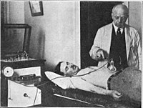

* Today, although small Tesla coils are used as leak detectors in scientific high vacuum systems and igniters in arc welders, their main use is entertainment and education displays.

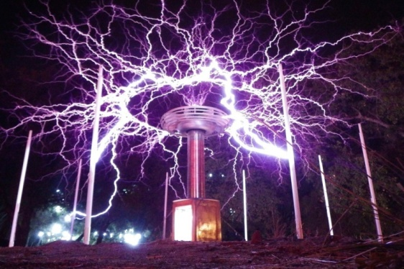

* Tesla coils are built by many high-voltage enthusiasts, research institutions, science museums, and independent experimenters.
* Although electronic circuit controllers have been developed, Tesla’s original spark gap design is less expensive and has proven extremely reliable.

**Pros:**

* Can reduce the use wires wherever possible(where the wires get clumsy).

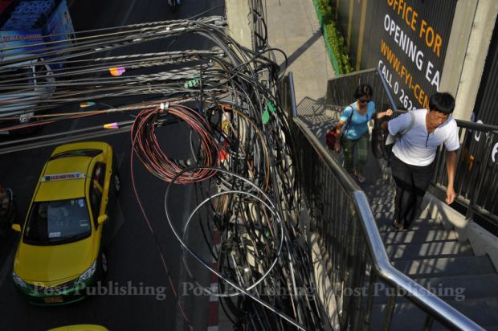

* The transmitter coil and the receiver coil should have same frequency for this to happen so connections can be made for specific coils.
* These coils can also be used to transmit power if the primary and secondary have same frequency and if their no of turns is same then it is just passing of current(by induction)with the same magnitude.
* Mini tesla coils(portable) can also be used in some places.

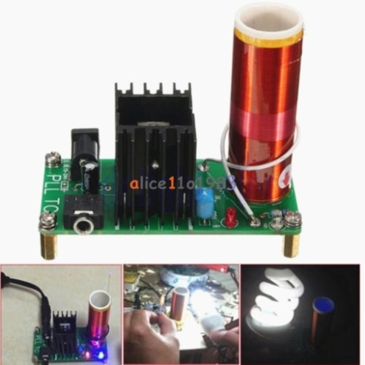

**Cons:**

* More complex circuit is required for more efficiency.
* Large DC smoothing capacitor is needed unless 3 phase power is used. Such a capacitor is expensive, and stores lethal energy.
* High voltage, high inductance charging inductor is needed. This is a specialized part and may be difficult to obtain.
* Required a 3-phase supply to be most effective.

Mathematics used/involved

I=V/R

P=VI=IR2

Q=CV

E= (1/2) QV= (1/2) CV2

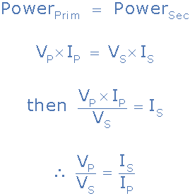

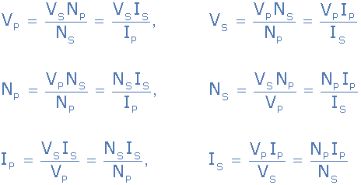

**Conclusion:**

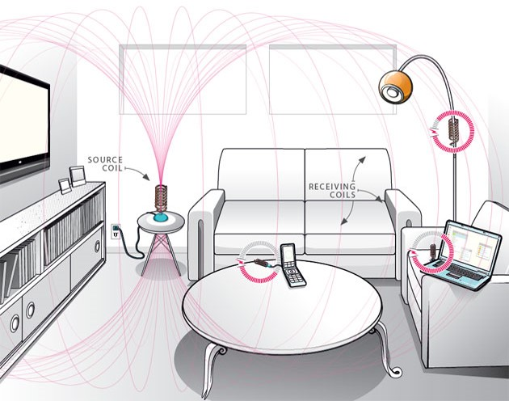

* The main objective was to demonstrate wireless power transmission using tesla coils.An effective tesla coil can supplypower to a whole room.
* Tesla coils are remarkable devices able to generate high voltage, high frequency waveforms with little control circuitry.
* Most of the builders of Tesla coils are interested in producing electric arcs and visible effects suitable for displays and general amusement, not in producing power supplies and power effects units which may have significant practical importance.
* It has demonstrated that tesla coils can be designed for wireless power transmission.

Bibliography

* English Wikipedia. Nikola Tesla, <http://en.wikipedia.org/wiki/Nikola_Tesla>
* <http://www.juliantrubin.com/encyclopedia/electronics/tesla_coil.htmlwww.idc>
* online.com/technical_references/pdfs/.../Introduction_to_Tesla_coil.pdf
* <https://en.wikipedia.org/wiki/Tesla_coil>
* [www.teslacoildesign.com](http://www.teslacoildesign.com)
* <https://www.quora.com/What-are-the-applications-of-Tesla-coil>
* Google images – tesla coil, uses and applications